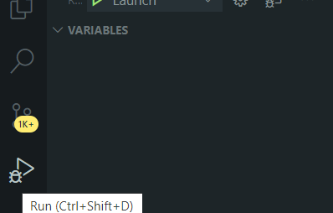

Plugins Debuggin Golang

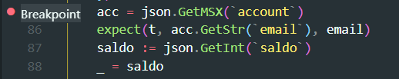

Adding Breakpoints

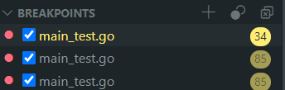

List Breakpoints

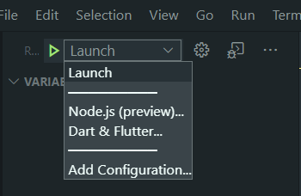

Running Code

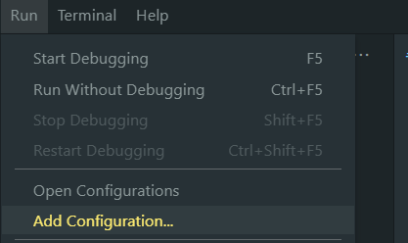

Adding Configuration Launch

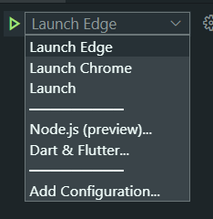

After Setting Configuration

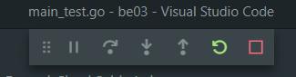

Debugging On Progress

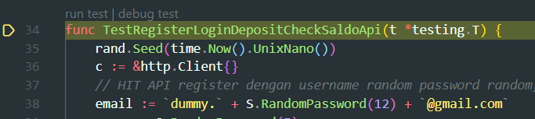

Stop when pointer is same with breakpoint line code

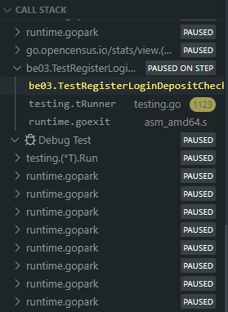

Call Stack

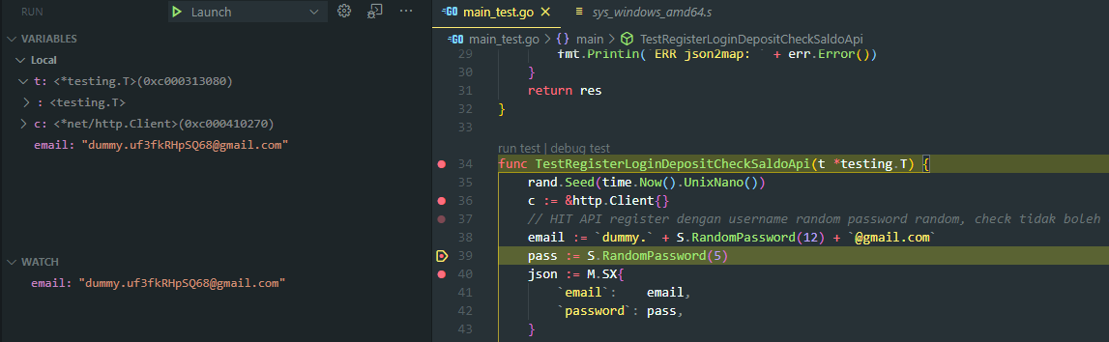

Debugging Email and show email dummy